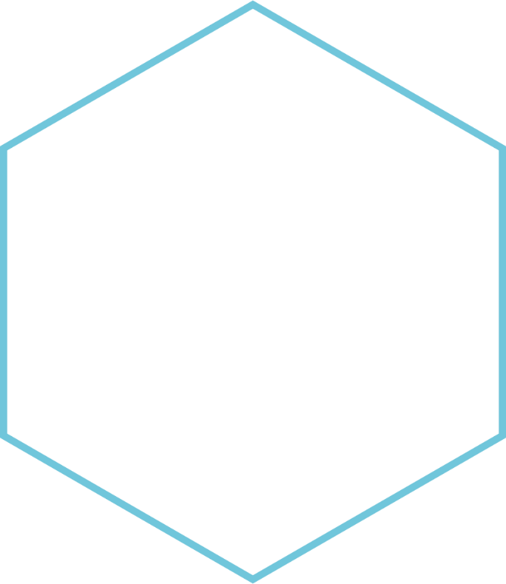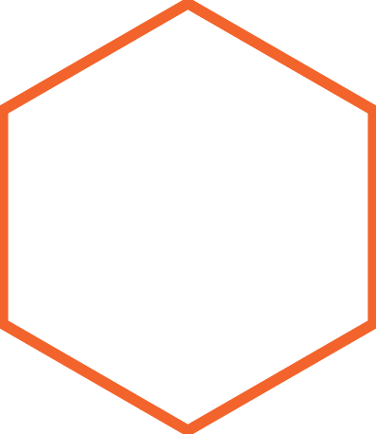

|  |
| --- |
| ASSIGNMENT 03 – Centrality Measures  **GRAPH ALGORITHMS** |
|  |
| **MUHAMMAD HARRIS**  *BCS203193* |
|  |



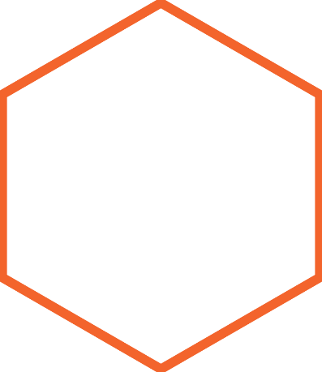

Table of Contents

**Python Program** 3

Code 3

**Screenshots** 5

**Python Program with UI** 8

Code 8

**Screenshot** 14

# ***Table of Figures***

Figure 1: Program Menu 5

Figure 2: Visualize Graph 6

Figure 3: Degree of all nodes 6

Figure 4: Degree Centrality 7

Figure 5: Betweenness Centrality 7

Figure 6: Closeness Centrality 8

Figure 7: Initial Screen 14

Figure 8: Excel File Selection 15

Figure 9: Post Selection Screen 15

Figure 10: Visualize Graph UI 16

Figure 11: Degree of Nodes UI 16

Figure 12: Degree Centrality UI 17

Figure 13: Betweenness Centrality 17

Figure 14: Closeness Centrality 18

GRAPH ALGORITHMS

ASSIGNMENT 03 – Centrality Measures

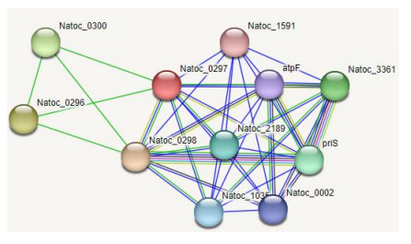Consider the following biological network of NATOC protein with its interactions with other proteins as shown in the figure below. (Excel file of dataset containing edges is provided)

Perform the following tasks:

1. Read the dataset file in Python

2. Identify the unique proteins and display them which represents the nodes

3. Calculate the degrees of all the nodes

4. Save the edges in a list after reading from excel file.

5. Identify the important proteins using:

a. Degree Centrality

b. Betweenness Centrality

c. Closeness Centrality

6. Show the results of all centrality measures along with values.

# Python Program

## Code

# MUHAMMAD HARRIS - BCS203193

# Graph Algorithms - Assignment 3

import networkx

import pandas

import os

import matplotlib.pyplot

import openpyxl

menu = """*GRAPH ALGORITHM ASSIGNMENT*

1. Visualize Graph

2. Degrees of all Nodes

3. Degree Centrality

4. Betweenness Centrality

5. Closeness Centrality

6. Exit"""

# function to visualize the graph

def visualizeGraph(g):

    networkx.draw(g, pos=networkx.spring_layout(g), with_labels=True, node_size=1000, node_color='#49be25')

    matplotlib.pyplot.show()

# function to display degree of all nodes

def printDegrees(g, nodes):

    print('\nDegree of all nodes:')

    for n in nodes:

        print(n, ' = ', graph.degree(n))

# function to display degree centrality

def printDegreeCentrality(g, nodes):

    print('\nDegree Centrality:')

    degreeCentrality = networkx.degree_centrality(g)

    for n in nodes:

        print(n, ' = ', degreeCentrality[n])

# function to display betweenness centrality

def printBetweennessCentrality(g, nodes):

    print('\nBetweenness Centrality:')

    betweennessCentrality = networkx.betweenness_centrality(g)

    for n in nodes:

        print(n, ' = ', betweennessCentrality[n])

# function to display closeness centrality

def printClosenessCentrality(g, nodes):

    print('\nCloseness Centrality:')

    closenessCentrality = networkx.closeness_centrality(g)

    for n in nodes:

        print(n, ' = ', closenessCentrality[n])

# main

# importing data from .xlsx file

filePath = r'C:\Users\Harri\OneDrive\Desktop\Assignment3_Dataset.xlsx'

data = pandas.read_excel(filePath)

# creating graph using data from .xlsx file

graph = networkx.Graph()

for i in range(0, len(data)):

    graph.add_edge(data.iloc[i, 0], data.iloc[i, 1]) # creating edge between columns of each row of Excel sheet

# creating a node list of graph

nodeList = graph.nodes()

# menu system

while True:

    os.system('cls')

    print(menu)

    option = input('option: ')[0]

    if option == '1':

        visualizeGraph(graph)

    elif option == '2':

        printDegrees(graph, nodeList)

        input('\npress enter key to return to menu...')

    elif option == '3':

        printDegreeCentrality(graph, nodeList)

        input('\npress enter key to return to menu...')

    elif option == '4':

        printBetweennessCentrality(graph, nodeList)

        input('\npress enter key to return to menu...')

    elif option == '5':

        printClosenessCentrality(graph, nodeList)

        input('\npress enter key to return to menu...')

    elif option == '6':

        break

    else:

        continue

### 

### **Screenshots**

Figure 1: Program Menu

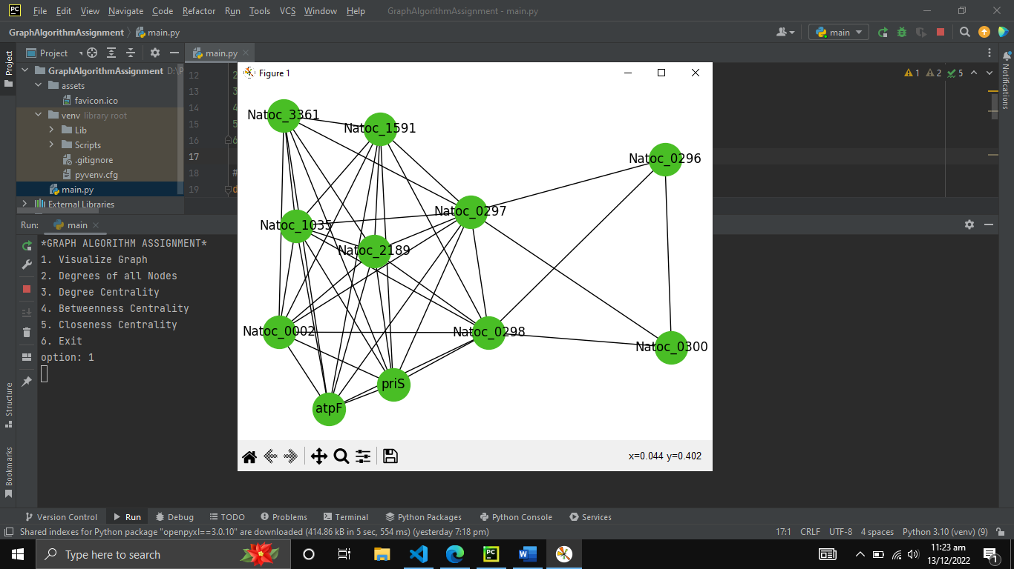

Figure 2: Visualize Graph

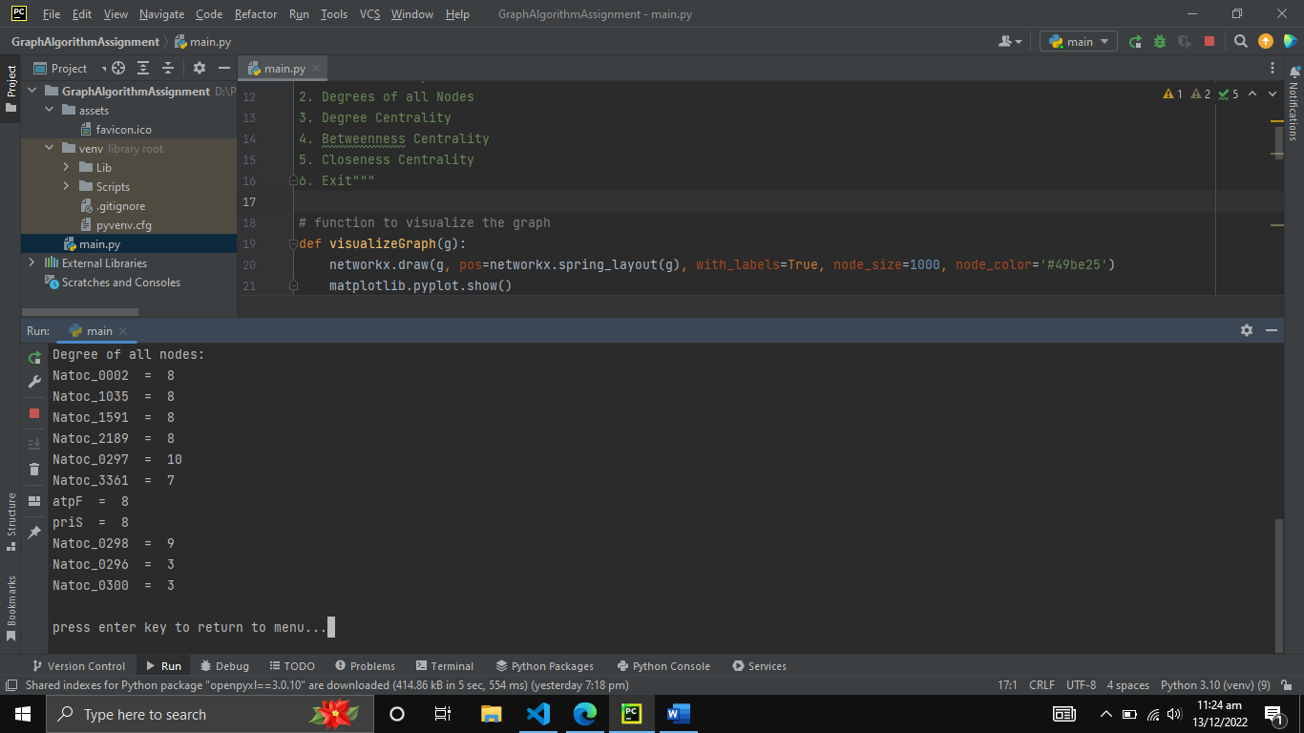

Figure 3: Degree of all nodes

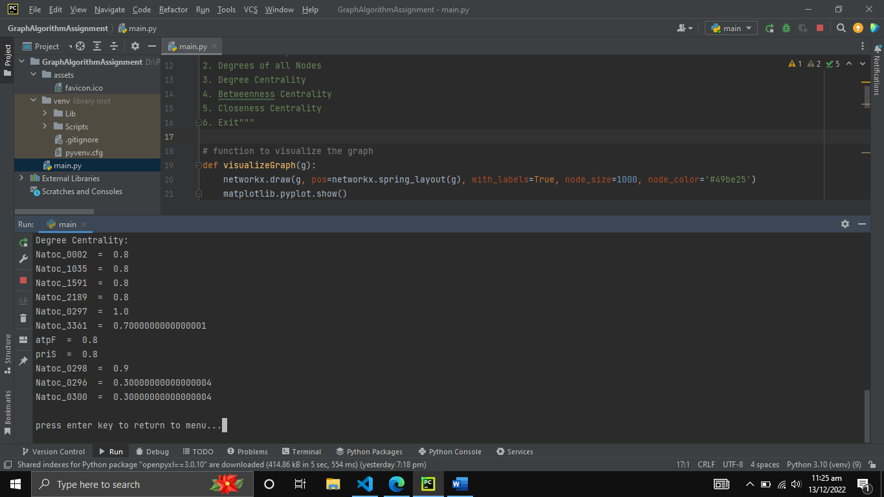

Figure 4: Degree Centrality

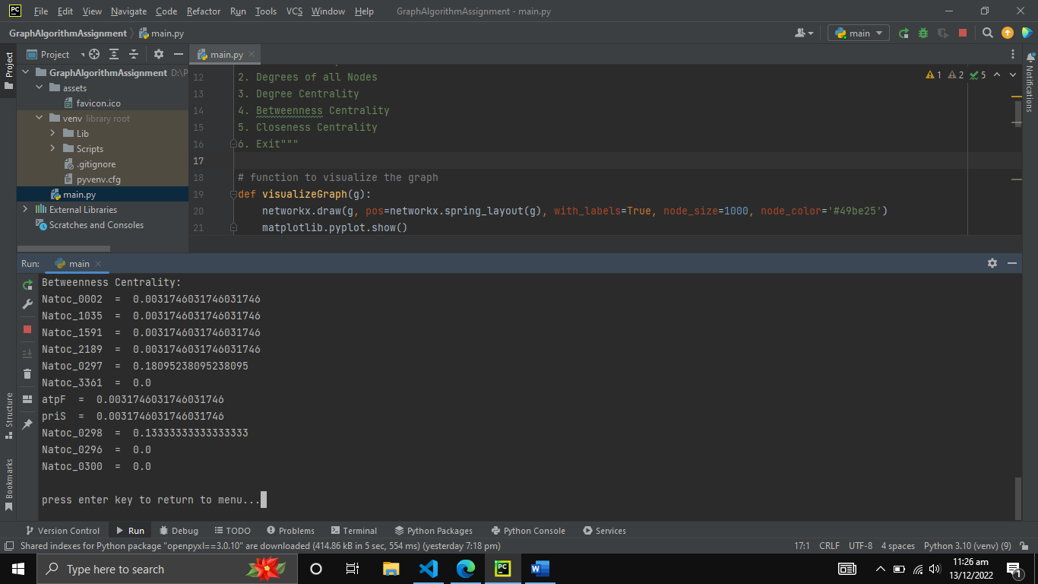

Figure 5: Betweenness Centrality

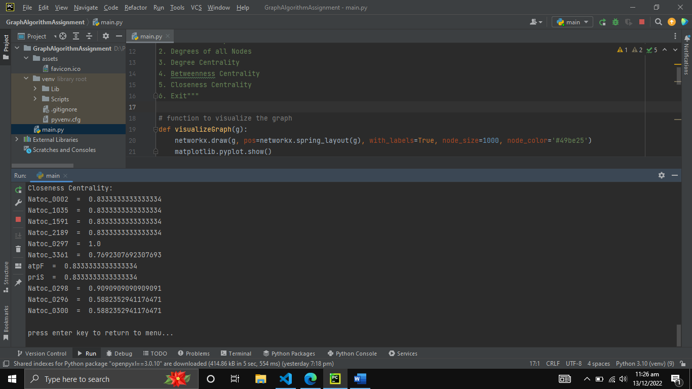

Figure 6: Closeness Centrality

# **Python Program with UI**

## Code

# MUHAMMAD HARRIS - BCS203193

# Graph Algorithms - Assignment 3

import networkx

import pandas

import matplotlib.pyplot

import openpyxl

from tkinter import *

import tkinter.filedialog

# init graph

mainGraph = networkx.Graph()

# init fileDirectory

fileDirectory = 'NULL'

# function to select excel file and create graph from it

def selectExcelFile():

    global fileDirectory

    global statusLabel

    global mainGraph

    fileTypes = (('excel files', '*.xlsx'), ('All files', '*.*'))

    fileDirectory = tkinter.filedialog.askopenfilename(title='Select excel file to create graph', initialdir='/', filetypes=fileTypes)

    statusLabel.config(text='STATUS: excel file selected', fg='#2ce20f')

    excelData = pandas.read_excel(fileDirectory)

    for i in range(0, len(excelData)):

        mainGraph.add_edge(excelData.iloc[i, 0], excelData.iloc[i, 1])

# function to visualize the graph

def visualizeGraph():

    networkx.draw(mainGraph, pos=networkx.spring_layout(mainGraph), with_labels=True, node_size=1000, node_color='#49be25')

    matplotlib.pyplot.show()

# create window that displays degree of nodes

def displayNodeDegree():

    # create node list

    nodeList = mainGraph.nodes()

    # create new window

    new = Tk()

    new.title('Degree of Nodes')

    new.geometry('560x520')

    new.resizable(False, False)

    new.iconbitmap(r'D:\Project\GraphAlgorithmAssignment\assets\favicon.ico')

    # null label

    nullLabel3 = Label(new, text='\n')

    nullLabel3.pack()

    textLabel = Label(new, text='DEGREE OF ALL NODES')

    textLabel.pack()

    # null label

    nullLabel4 = Label(new, text='\n')

    nullLabel4.pack()

    # display nodes along with degree

    for n in nodeList:

        label = Label(new, text=n + ': ' + str(mainGraph.degree(n)))

        label.pack()

# create window that displays degree centrality of nodes

def displayDegreeCentrality():

    # create node list

    nodeList = mainGraph.nodes()

    # create new window

    new = Tk()

    new.title('Degree Centrality of Nodes')

    new.geometry('560x520')

    new.resizable(False, False)

    new.iconbitmap(r'D:\Project\GraphAlgorithmAssignment\assets\favicon.ico')

    # null label

    nullLabel3 = Label(new, text='\n')

    nullLabel3.pack()

    textLabel = Label(new, text='Degree Centrality')

    textLabel.pack()

    # null label

    nullLabel4 = Label(new, text='\n')

    nullLabel4.pack()

    # get degree centrality as a dictionary

    degreeCentrality = networkx.degree_centrality(mainGraph)

    # display nodes along with degree centrality

    for n in nodeList:

        label = Label(new, text=n + ': ' + str(degreeCentrality[n]))

        label.pack()

# create window that displays betweenness centrality of nodes

def displayBetweennessCentrality():

    # create node list

    nodeList = mainGraph.nodes()

    # create new window

    new = Tk()

    new.title('Betweenness Centrality of Nodes')

    new.geometry('560x520')

    new.resizable(False, False)

    new.iconbitmap(r'D:\Project\GraphAlgorithmAssignment\assets\favicon.ico')

    # null label

    nullLabel3 = Label(new, text='\n')

    nullLabel3.pack()

    textLabel = Label(new, text='Betweenness Centrality')

    textLabel.pack()

    # null label

    nullLabel4 = Label(new, text='\n')

    nullLabel4.pack()

    # get betweenness centrality as a dictionary

    betweennessCentrality = networkx.betweenness_centrality(mainGraph)

    # display nodes along with degree centrality

    for n in nodeList:

        label = Label(new, text=n + ': ' + str(betweennessCentrality[n]))

        label.pack()

# create window that displays closeness centrality of nodes

def displayClosenessCentrality():

    # create node list

    nodeList = mainGraph.nodes()

    # create new window

    new = Tk()

    new.title('Closeness Centrality of Nodes')

    new.geometry('560x520')

    new.resizable(False, False)

    new.iconbitmap(r'D:\Project\GraphAlgorithmAssignment\assets\favicon.ico')

    # null label

    nullLabel3 = Label(new, text='\n')

    nullLabel3.pack()

    textLabel = Label(new, text='Closeness Centrality')

    textLabel.pack()

    # null label

    nullLabel4 = Label(new, text='\n')

    nullLabel4.pack()

    # get closeness centrality as a dictionary

    closenessCentrality = networkx.closeness_centrality(mainGraph)

    # display nodes along with degree centrality

    for n in nodeList:

        label = Label(new, text=n + ': ' + str(closenessCentrality[n]))

        label.pack()

# main

# creating UI

root = Tk()

root.geometry('560x520')

root.resizable(False, False)

# add favicon to window

root.iconbitmap(r'D:\Project\GraphAlgorithmAssignment\assets\favicon.ico')

# adding window title

root.title('Graph Algorithms - Assignment 3 - MUHAMMAD HARRIS - BCS203193')

# null label

nullLabel0 = Label(root, text='\n')

nullLabel0.pack()

# creating label

headingLabel = Label(root, text='GRAPH ALGORITHMS')

headingLabel.pack()

# null label

nullLabel = Label(root, text='\n')

nullLabel.pack()

# file frame

fileFrame = LabelFrame(root, text='Select excel file to create graph', padx=10, pady=10)

fileFrame.pack()

# select file

selectFileButton = Button(fileFrame, text='Open File', command=selectExcelFile)

selectFileButton.pack()

# status label for excel file

statusLabel = Label(fileFrame, text='STATUS: no file selected', bd=1, relief=SUNKEN, padx=3, fg='#E2260f')

statusLabel.pack(pady=10)

# null label

nullLabel2 = Label(root, text='\n')

nullLabel2.pack()

# creating menu frame

menuFrame = LabelFrame(root, text='Options for graph', padx=10, pady=10, labelanchor='n')

menuFrame.pack(padx=10, pady=10)

# creating button for visualizing graph

button_visualizeGraph = Button(menuFrame, text='Visualize Graph', command=lambda: visualizeGraph(), padx=22.5)

button_visualizeGraph.pack(pady=5)

# creating button for degree of nodes

button_nodeDegrees = Button(menuFrame, text='Degree of Nodes', padx=18.5, command=lambda: displayNodeDegree())

button_nodeDegrees.pack(pady=5)

# creating button for degree centrality

button_degreeCentrality = Button(menuFrame, text='Degree Centrality', padx=16.5, command=lambda: displayDegreeCentrality())

button_degreeCentrality.pack(pady=5)

# creating button for betweenness centrality

button_betweennessCentrality = Button(menuFrame, text='Betweenness Centrality', command=lambda: displayBetweennessCentrality())

button_betweennessCentrality.pack(pady=5)

# creating button for closeness centrality

button_closenessCentrality = Button(menuFrame, text='Closeness Centrality', padx=9, command=lambda: displayClosenessCentrality())

button_closenessCentrality.pack(pady=5)

# run UI

root.mainloop()

### **Screenshot**

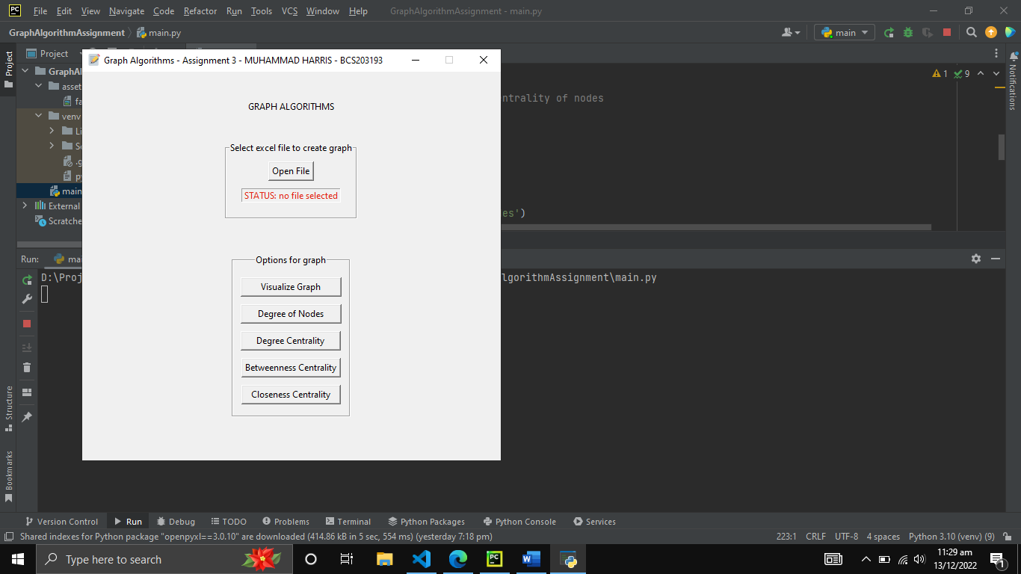

Figure 7: Initial Screen

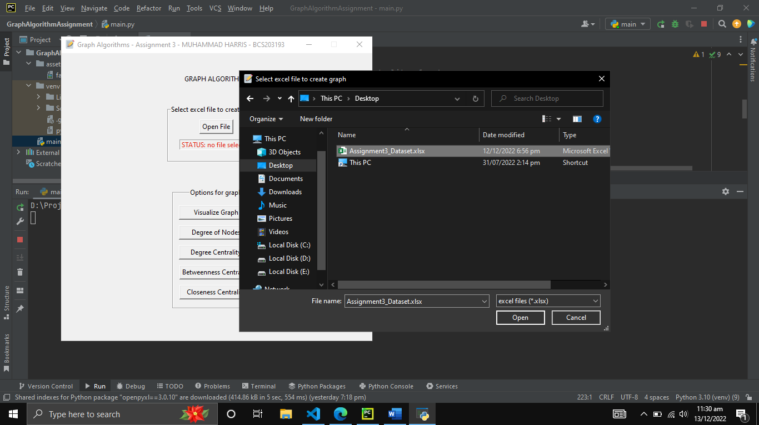

Figure 8: Excel File Selection

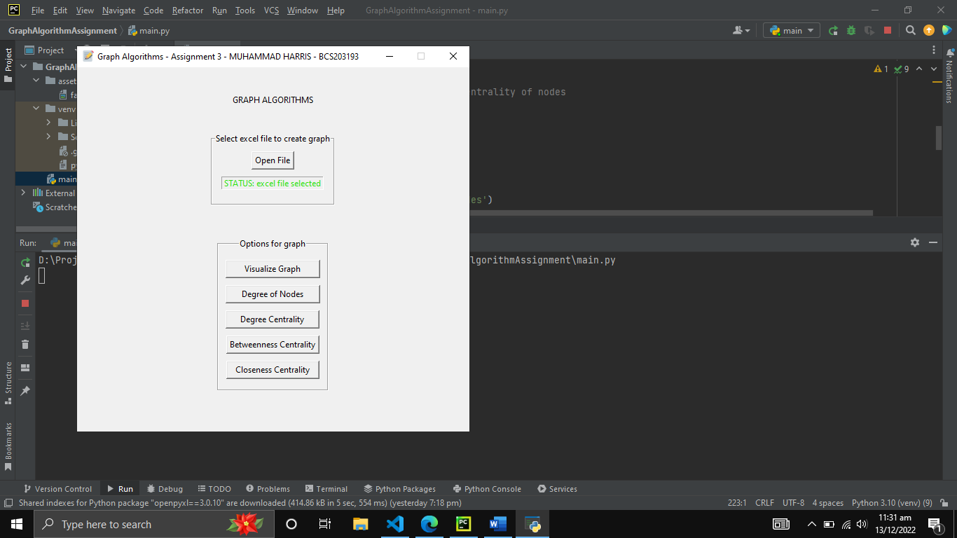

Figure 9: Post Selection Screen

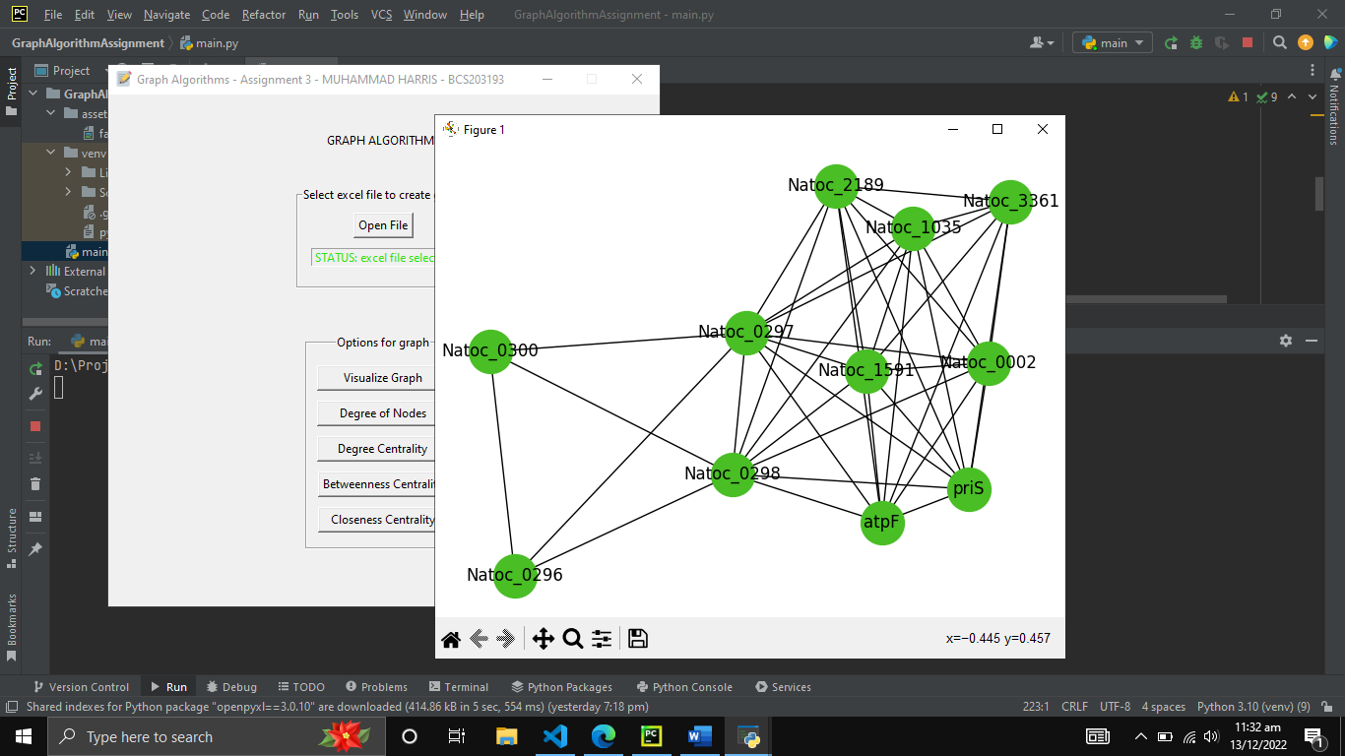

Figure 10: Visualize Graph UI

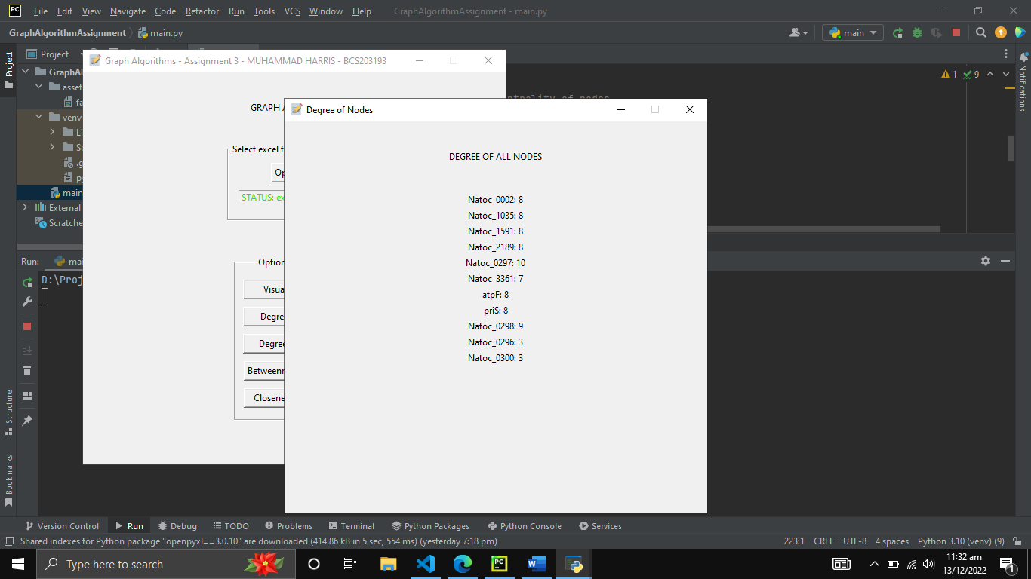

Figure 11: Degree of Nodes UI

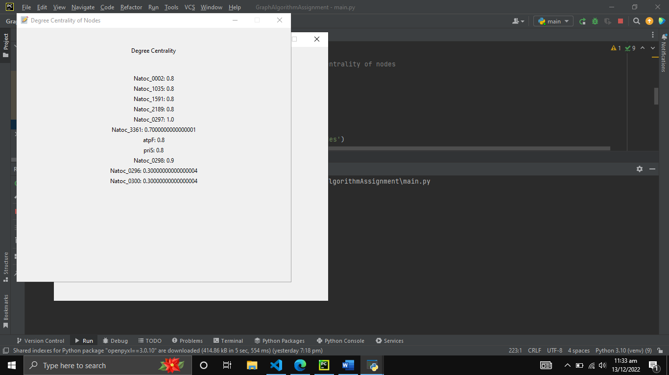

Figure 12: Degree Centrality UI

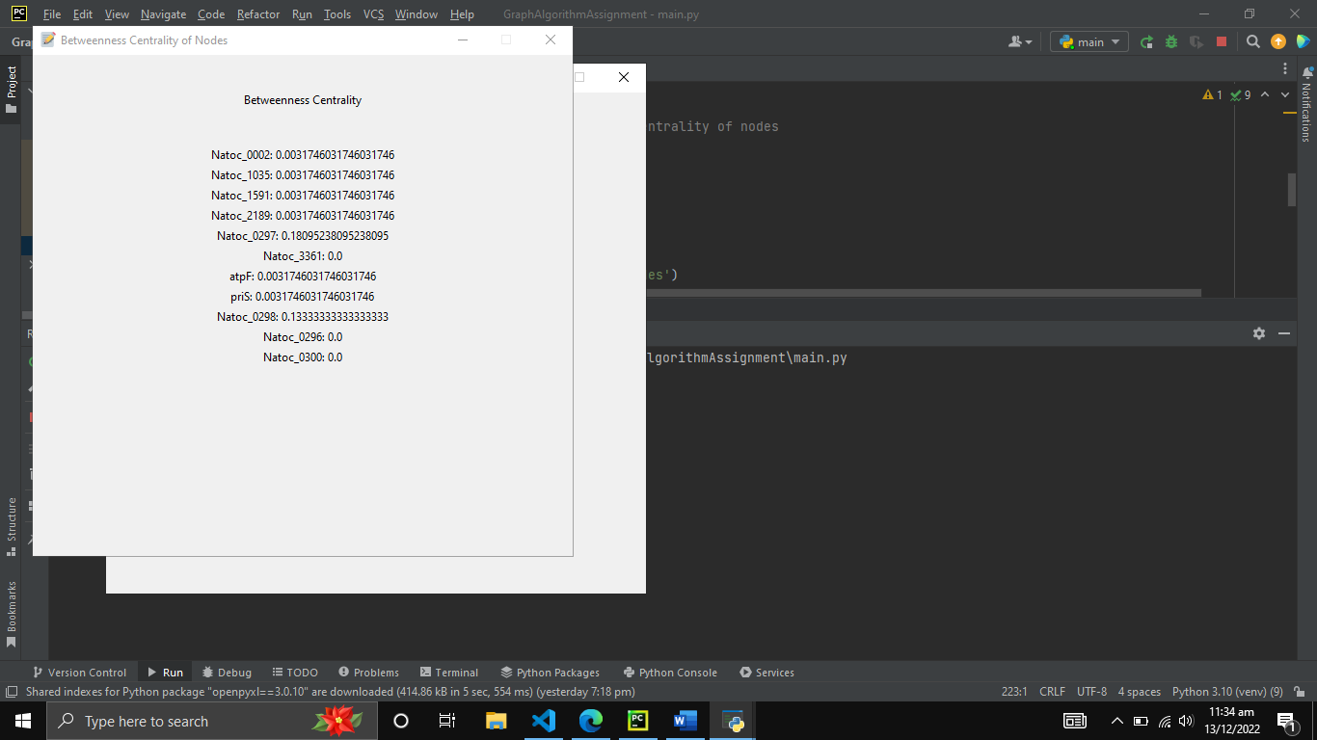

Figure 13: Betweenness Centrality

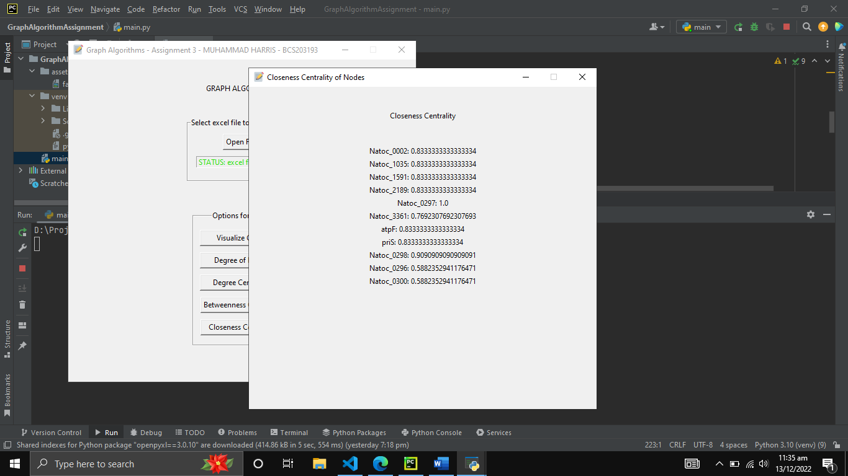

Figure 14: Closeness Centrality